IA-3
2016 IE Strategy Memorandum

Updated on 4/18/16
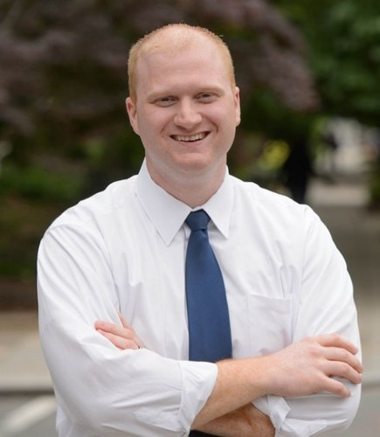
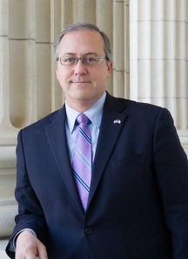

JIM MOWRER DAVID YOUNG
CoH: $437,635.19 CoH: $956,096.10
Date: 4/15/16 Date: 4/15/16
Occupation: Sergeant National Guard (ret.) Occupation: Congressman
Special Assistant to Under Secretary of Army
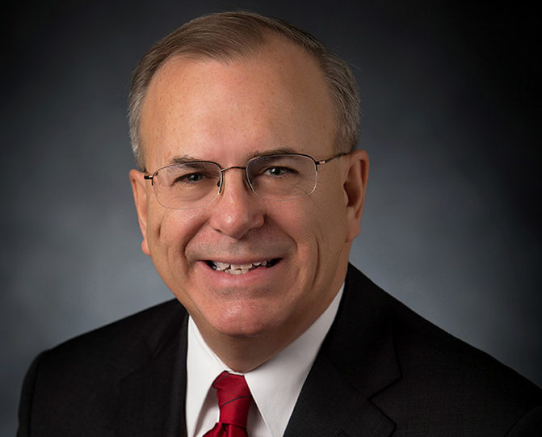

MIKE SHERZAN
CoH: $205,861.23
Date: 4/15/16
Occupation: CEO (ret)

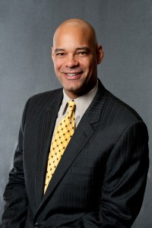

DESMUND ADAMS
CoH: $2,644.47
Date: 4/15/16
Occupation: Business Owner

SECTION I: Race Overview
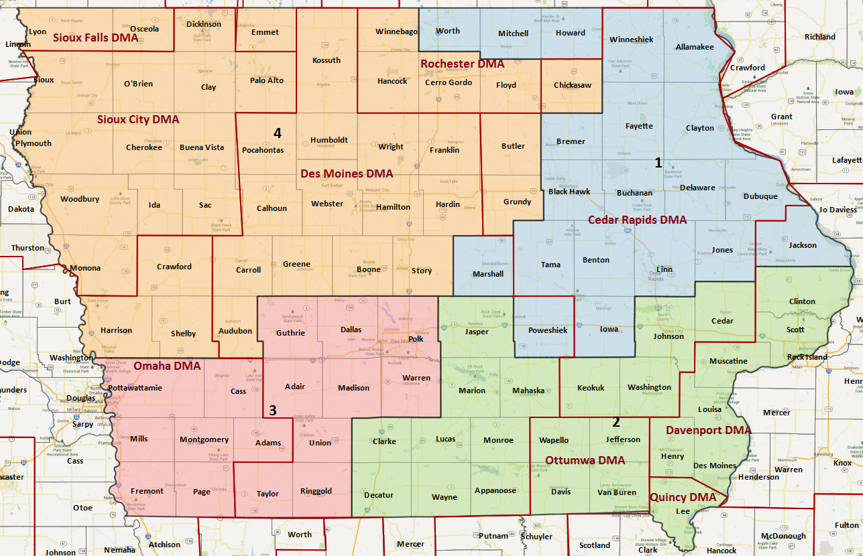

District/Media Market Map

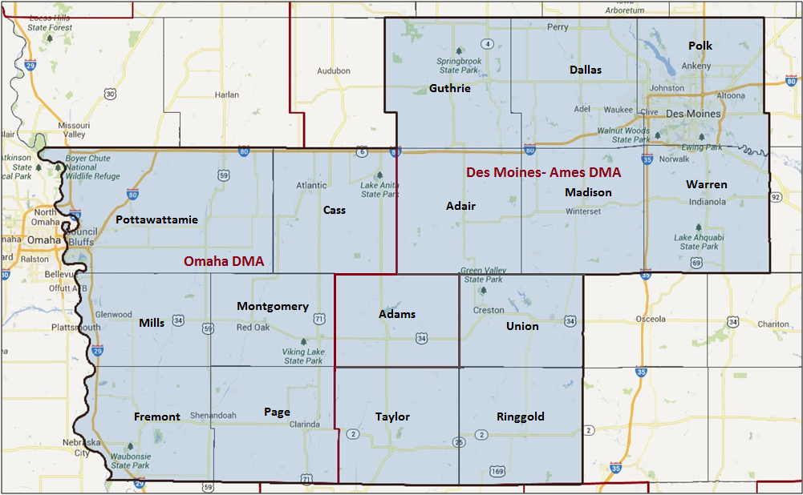

Media Market Costs

TV DMA | % of  CD | I.E.  35+ CPP | Cable CPP
OMAHA | 18% | $162 | $110
DES MOINES - AMES | 82.1% | $301 | $227
IA-03 TOTALS: | 100%
Radio Landscape

Des Moines
Universe Size | CPP
318,000 | $100

Omaha
Universe Size | CPP
55,100 | $165

Digital Landscape
- IA-03
  - Persuasion universe size: 34,188
  - Audience extension (key demos): 30-45
  - Weekly budget for full coverage: $ $10,390.02
  - Reach
    - YouTube - 369,079
    - Pandora - 160,509

Presidential Statistics
Cycle | Candidate | Party | Vote
2012 | Obama | DEM | 52.2%
2012 | Romney | REP | 47.8%
2008 | Obama | DEM | 53.2%
2008 | McCain | REP | 46.8%

Congressional Statistics
Cycle | W/L | Candidate | Party | Vote
2014 | L | APPEL | DEM | 44.46%
2014 | W | YOUNG | REP | 55.54%
2012 | L | BOSWELL | DEM | 45.5%
2012 | W | LATHAM | REP | 54.5%

NCEC Data
Dem Performance: 51.1%
BVAP: 3.3%
Hispanic: 2.8%
Native Amer.: N/A
Asian: 1.7%
Total Minority: 7.8%
Party Registration: N/A

Critical Dates
Filing Date: March 18th 2016
Primary Date: June 7th 2016

Summary of 2014 Cycle Spending by Outside Groups to Date

Des Moines – Ames

Campaign/Group | Total GRPs | Total Dollars
Young/NRCC | 376 | $28,185
NRCC | 7,901 | $2,208,059
DCCC | 11,390 | $1,794,895
House Majority PAC | 2,001 | $318,995
Americans for Responsible Solutions | 641 | $250,500
Mayday PAC | 1,989 | $777,317
National Rifle Association | 1,883 | $449,065

Good Guys vs Bad Guys | Total GRPs | Total Dollars
Good Guys | 16,021 | $3,141,707
Bad Guys | 101,60 | $2,685,309

TV Competitive Summary – Omaha
Campaign/Group | Total GRPs | Total Dollars
NRCC | 4,493 | $928,930
DCCC | 2,952 | $559,270
House Majority PAC | 800 | $97,240
Americans for Responsible Solutions | 77 | $7,851

Good Guys vs Bad Guys | Total GRPs | Total Dollars
Good Guys | 3,829 | $664,361
Bad Guys | 4,493 | $928,930

Radio Competitive Summary – Des Moines
Campaign/Group | Total GRPs | Total Dollars
NRA | 462 | $17,570
DCCC | 1,250 | $147,005

Good Guys vs Bad Guys | Total GRPs | Total Dollars
Good Guys | 1,250 | $147,005
Bad Guys | 462 | $17,570

Summary of Digital Program:

The 2014 DCCC IE Program was up for a total of 8 weeks in the Des Moines Market (weeks 8-1), with a total of 46,649 matches and 6,402,877 impressions with 1,387,342 video impressions in the Des Moines. In mid-September for 2.5 weeks we ran the message from our television creative via pre-roll video and complimentary banner advertising to cookie-matched voters registered in the treatment zip codes, along with internet users matching our persuasion universe’s demographics located in the treatment zip codes.

Summary of 2012 Spending by Outside Groups

TV Competitive Summary – Omaha
Campaign/Group | Total GRPs | Total Dollars
DCCC | 4,100 | $568,050
NRCC | 2,750 | $365,656
Patriot Majority | 996 | $134,360
Congress. Leadership Fnd. | 2,518 | $390,155
Realtors PAC | 1,573 | $308,760
Center for Individual Freedom | 953 | $161,480
Crossroads GPS | 2,232 | $613,719

Good Guys vs Bad Guys | Total GRPs | Total Dollars
Good Guys | 4100 | $568,050
Bad Guys | 11,022 | $1,974,130

TV Competitive Summary – Des Moines

Campaign/Group | GRPs | Total Dollars
DCCC | 4,700 | $899,835
Boswell/Iowa Democratic Party | 975 | $82,314
Center for Individual Freedom | 720 | $173,306
Crossroads GPS | 3,036 | $598,650
House Majority PAC | 233 | $31,500

Good Guys vs Bad Guys | Total GRPs | Total Dollars
Good Guys | 5,675 | $1,013,649
Bad Guys | 3,756 | $771,956
Pre-Election Day Voting

Type of  “Early Voting” | Start Date  End Date | Percent of  Vote Cast Using this Method | Brief Description  (where/how  do people vote) | Timeframe (when does the majority of voting happen)
In person Early Vote | Sep 29 – Nov 7 |  | Starting 40 days from the election, voters can cast an absentee ballot at their county auditor’s office. | Steadily between Sep 29 – Nov 7
Absentee Ballot/Vote By Mail | Sep 29 – Nov 7 |  | No later than 40 days before Election Day, absentee ballots will be sent to anyone who submitted a request. No excuse is needed. | The largest numbers of ballots are returned on the first day of Early Voting (around 20% of early ballots cast in 2014). From that point on, daily returns are relatively steady.

Tentative Campaign Timeline

IMPORTANT DATES

Early Vote: Sep 29 – Nov 7
VBM: Sep 29 – Nov 7

SECTION II: DISTRICT OVERVIEW

- District Overview and Data

  - Political Landscape
- David Young, a sixth generation Iowan, served as the Chief of Staff to Senator Chuck Grassley from 2006 to 2013. He was first elected in 2014 following the retirement of Republican Representative Tom Latham.

- Jim Mower ran for office in IA-04 in 2014. He previously served the longest tour of duty of any unit as a Sergeant in Operation Iraqi Freedom while in the Iowa National Guard and later was appointed Special Assistant to the Under Secretary of the Army. While Young ran in the 4th last cycle, he has lived in the 3rd longer than Young in the last decade. Mowrer was close with Beau Biden and has the support of Hunter Biden.

- Mike Sherzan is a successful local businessman who was born and raised in Des Moines. Sherzan has the potential to completely self-fund his campaign and has already loaned the campaign $298,000 (Q1 2016). Sherzan's brothers, Gary and Richard Sherzan, are both former Democratic state legislators.

- Desmund Adams is a motivational speaker and businessman. He has struggled to raise money, garner endorsements, or receive any sustained attention.

- 2014 According to the IE exit memo on IA-3, in 2014 this was one of the best opportunities to pick up a seat. As a whole, the ads Three Point did here were some of the best and most creative the IE had this cycle, and a big part of why the race was as close as it was. However, Des Moines was a crowded market and it was difficult to break through and differentiate Appel from the Democratic brand. Additionally, while it was a smaller market, Omaha became important given how close the race was—so future plans should consider the very real possibility of having to play significantly in both markets.
- Young was the 5th place candidate after the Republican primary, so we had hoped that he would have to spend more time consolidating the Republican base than he did. There was a path to victory from early polling, and we were able to keep the race close. However, several factors contributed to Young’s eventual victory: Braley’s campaign faltered, the Iowa airways were extremely crowded with significant anti-Democratic messaging and the national climate became increasingly hostile to Democrats. Neither Young nor Appel ran particularly coherent or strong campaigns—even Republicans commented about how odd Young’s strategy seemed to be. They helped However, there was little that Appel could capitalize on to fully disqualify him in such a bad year for Democrats. That said, a stronger candidate and more tightly-run campaign could certainly be successful here in a presidential year.

  - District Demographics
- Iowa’s 3rd Congressional District is located in the southwestern corner of the state, stretching from Council Bluffs along the Nebraska border to Des Moines in the northeast.
- The district’s population is grounded in Polk County (home to Des Moines) at 55.2% of the total expected vote, adjacent Dallas County (10.2% of expected vote), and Pottawattamie County (home to Council Bluffs, 11.6% of expected vote) – with rural, sparsely populated communities in between. As a result, the district is a mix of suburban (48.7%) and rural (43.9%) locales, and home to a combination of blue collar workers in the agriculture and manufacturing sectors as well as financial services industry workers to support them. Notably, the DPIs for both Polk and Pottawattamie have increased by 0.5 and 0.3 points respectively since 2012, as a sign of Democratic growth in each region, while DPIs in the rural counties have been shifting away from Democrats.
- Although the Hispanic and African American populations combined make up just 6.1% of the total Citizen Voting Age Population (CVAP) in the district, they are slightly more predominant in Polk County (1.35% Hispanic/ Latino, 3.06% African American) and Pottawattamie County (0.30% Hispanic/ Latino, 0.17% African American) regions.

District Demographics

- Cook Partisan Voting Index: Even
- Urban Population: 7.3%
- Rural Population: 43.9%
- Median Income: $59,460
- Poverty Status: 7.2%
- Military Veterans: 10.2%
- Race/Ethnic Origin: 83.9% White; 8.3% Black; 3.3% Asian; 1.7% Native Am; N/A Hispanic Origin; 2.8%
- Occupation: N/A

  - Electoral Context
- Though no third party candidates have declared yet for 2016, they have been a factor in the two most recent elections. In 2014, a Libertarian and nominated by petition candidates received 4.7% combined support, likely at the expense of Republicans, while in 2012, a Socialist and another nominated by petition candidate received 3.9% support.
- This district is inherently tied to Sen. Grassley as Young is a former staffer and campaigned heavily on his association with the popular Senator. He is up for election this cycle and will be a part of the overall political landscape. Senator Chuck Grassley has come under fire for refusing to even consider an Obama appointee to the Supreme Court. He is viewed as untouchable in Iowa but his public beating led to a more serious challenge from former Lt. Governor Patty Judge. Nationally, this is viewed as the best example of a referendum on judicial obstruction.
- Iowa will be a critical center of presidential campaign activity. The presidential campaign is expected to focus on turnout efforts in Des Moines (and possibly Council Bluffs), but is unlikely to engage in a broader persuasion effort across the rest of the district which congressional Democrats will require. The presidential campaign does not have to win the district in order to win the state, though will need to be competitive in the district.
- There are no ballot initiatives yet, and no significant changes have been made in voting laws since the 2014 cycle.

  - Press Presence
- The district is comprised of two media markets; Des Moines and Omaha. The Des Moines media market covers 83% of the total district and has a cost per point of $301, the Omaha market covers the left over 17% of the district and has a $162 current cost per point.
- The DCCC and the Mowrer campaign has struggled to garner earned media in Des Moines. It was particularly difficult leading up to the caucuses but the DCCC is gaining some more traction now that the presidential campaigns have left. This will continue to be a tough media market because there is one major newspaper and we don’t have secondary outlets to secure citations from.
- The Des Moines Register is the paper of record for the district and endorsed David Young in 2014, citing the need for Young’s “pragmatism” in congress.
- Des Moines
  - Des Moines Register
  - Iowa Public Radio
  - Radio Iowa
  - WHO Radio
  - WHO (NBC)
  - WOI (ABC)
  - KCCI (CBS)
  - KDSM (FOX)
  - Daily Democrat
  - Iowa Starting Line
  - Bleeding Heartland

SECTION III: MESSAGE

Message Box

Democrat Self Frame  Jim Mowrer’s commitment to service is the product of his experiences, his hardships, and his opportunities. Jim lived on a family farm until his father died in a farming accident, which forced his mother to move the family to Des Moines where she raised her children as a single mother. Jim served his country on the battlefield and at the Pentagon and is running for Congress to serve hardworking middle-class Iowans. | Republican Self Frame  David Young believes that optimism is at the center of America’s continued greatness, and is the defining character of David’s public service. He has committed himself to courageously standing against the waste, fraud, and mismanagement of your hard earned tax dollars.
Likeliest Attacks on Democrat  Mowrer is an overly ambitious, inexperienced candidate who is looking to run for congress to solve his money problems. He subscribes to the Washington democrat playbook and supports amnesty, abortion, and Obamacare. | Best Attacks on Republican  Career Washington Insider, David Young listens to extreme special interests and not the people of Iowa. Young votes with the Tea Party, including his opposition to the Highway Bill. He also voted to destroy Medicare as we know it and slash Pell Grants for students who need them.

- Jim Mowrer (D)

- Short Biography
Jim Mowrer ran for office in IA-04 in 2014. He previously served the longest tour of duty of any unit as a Sergeant in Operation Iraqi Freedom while in the Iowa National Guard and later was appointed Special Assistant to the Under Secretary of the Army. While Mowrer ran in the 4th last cycle, he has lived in the 3rd longer than Young in the last decade. Mowrer was close with Beau Biden and has the support of Hunter Biden.

- Self-Frame
Jim Mowrer’s commitment to service is the product of his experiences, his hardships, and his opportunities. Jim lived on a family farm until his father died in a farming accident, which forced his mother to move the family to Des Moines where she raised her children as a single mother. Jim served his country on the battlefield and at the Pentagon and is running for Congress to serve hardworking middle-class Iowans.

The above is sourced from his website, facebook, and DCCC campaign overview.

- Likely Attacks
Overly ambitious. Mowrer ran for Congress in two different districts before he turned 30.
NOTE: His perceived arrogance rubs some people the wrong way and makes this message more salient.
Shady Campaign Finance. (Unlanded) Mowrer is paying his wife and inappropriately paid for utilities and cell phone bills from his campaign account.

Skeptical Base. The base is skeptical of Mowrer -- he seems to be “always running for something” and over-stating his position, without ever winning.

Each of these hits are character based rather than issue. They will be harder to push back on, especially because he has ran before. Mowrer has done little to combat his image problem.

- Assessment of Democratic Fundraising
MEMBER/CANDIDATE | CYCLE RAISED | CYCLE SPENT | Q1 RAISED | COH
Jim Mowrer | $637,989.78 | $243,779.31 | $291,911.59 | $437,635.19

MOWRER | Q1 2015 | Q2 2015 | Q3 2015 | Q4 2015 | Q1 2016
Goal | N/A | N/A | $250,000 | $300,000 | $300,000
Actual Raised | N/A | N/A | $183,195 | $153,166 | $294,339

- Strengths and Weaknesses of Campaign

Strengths
  - Current COH advantage on Sherzan.
  - Largest Dem fundraiser
  - Name ID

Weaknesses
  - Character issues, likely high unfavs
  - Unlanded Campaign finance issues
  - Sherzan is self-funding
  - A large media buy by Sherzan in the primary could sink Mowrer.

- Mike Sherzan (D)

- Short Biography
Mike Sherzan was born and raised in Des Moines, Iowa. His father died young and Sherzan took several jobs to help support the family. He eventually graduated college and started his own Iowa based company that grew to over 60 employees. He retired in 2015.

- Self-Frame
For too long our government's politics have been rigged by special interest and driven by a cynicism that our greatest days are already behind us. As a Des Moines native, Mike Sherzan grew up in that time where he could start his own business and be successful. Mike is running to help us restore optimism in our communities and in our future by working to help everyone, not just the select few, build their own American Dream.

The above is sourced from his website, facebook, and DCCC campaign overview.

- Likely Attacks
Wall Street Banker. Sherzan is far wealthier than the district average.
No Record of Service.

- Assessment of Democratic Fundraising
MEMBER/CANDIDATE | CYCLE RAISED | CYCLE SPENT | Q1 RAISED | COH
Mike Sherzan | $350,506.88 | $142,145.65 | $122,921.64 | $205,861.23

SHERZAN | Q1 2015 | Q2 2015 | Q3 2015 | Q4 2015 | Q1 2016
Goal | N/A | N/A | N/A | $150,000 | $300,000
Actual Raised | N/A | N/A | N/A | $227,585 | $122,921

- Strengths and Weaknesses of Campaign

Strengths
  - Can self-fund
  - Small business owner
  - No legislative record

Weaknesses
  - May have tapped out his personal network
  - Name ID
- Republican Candidate

- Short Biography
David is a sixth generation Iowan. His family homesteaded in Pocahontas County in 1881. Emigrating from Germany. Upon graduating from high school, David attended his father’s and grandmother’s alma mater, Buena Vista College, and then went on to graduate from Drake University. Most recently, David served the people of Iowa in his role as Chief of Staff to Senator Chuck Grassley.
- Self-Frame
David Young believes that optimism is at the center of America’s continued greatness, and is the defining character of David’s public service. He has committed himself to courageously standing against the waste, fraud, and mismanagement of your hard earned tax dollars.

- Best Attacks

Republican Candidate | Ryan Budget(s) – (Include if its Votes or Statement) | Privatize Social Security | Defund Planned Parenthood | Anti-Choice Position
Young | Yes – Votes | Voted to jeopardize social security | Yes | Yes

Young Top Hits
- Young: Trump’s anti-Islamic comments are “tapping into a general frustration we all have.”
- Career Washington Insider. Young has literally spent his entire career in Washington collecting a check from the federal government. He’s a Washington insider —was chief of Staff to Senator Chuck Grassley and has worked for the federal government for the past twenty years.
- Flip flops on issues—voted against reauthorizing the Export-Import Bank saying he opposed the Bank but then voted for the highway trust fund bill even though it contained provision to reauthorize the Bank because the legislation included his proposal for a farm bill.
- Vehemently anti-choice—voted to require who had been raped and were seeking abortions to undergo a 48 hour waiting period.
- Extreme Views. Young votes with the Tea Party, including his opposition to the Highway Bill. He also voted to destroy Medicare as we know it and slash Pell Grants for students who need them.
- Young said he was proud of Ted Cruz trying to shut down the government over the ACA.
- Out-Of-Touch with Hardworking Iowans. Young has a house in DC worth over a million dollars and he moved to Iowa just so he could fulfill his political ambitions. When working on his bosses campaign, he worked the game to double-dip from both the government and the campaign.
- See “The Case against David Young” IA-03 Research Book.

SECTION V: Appendix

- 2016 Campaign Side Consulting Team
Media: Colin Rogero, 76 Words
Mail: Scott Simpson, Resonance Campaigns
Polling: Jason McGrath, GBA

- Summary of Past Races and Important Differences for 2016
Recent Elections
- In 2012, President Obama carried the district with 52.2% support overall. He received 57.2% support in Polk County, 44.1% support in Dallas, and 44.5% in the Omaha media market. His winning coalition was built on the strong support of women voters (56% support) as well as modeled Independent voters (58% support).
- In 2012, at the congressional level, Democratic Congressman Leonard Boswell faced fellow Congressman Latham as their two former seats were redrawn together. Boswell was defeated with just 45.5% of the vote; having only narrowly won Polk County (51.0% support, -6.2 points vs. Obama), and lost all other counties in the district as well as lower than necessary support in the Omaha market (37.8% support). Only 49% of women supported Boswell, as well as 47% of modeled Independents. Starting three weeks out from Election Day, Boswell was outspent in TV by over 1,000 GRPs, a spending difference the campaign was unable to make up.
- In 2014, Democratic congressional candidate Staci Appel lost the district with 44.5% of the two-way vote. The 2014 cycle was impacted by significant top of ticket drag, with Bruce Braley also losing the district with 45.7% of the vote. Appel faced very low turnout in 2014 as well, with only 59.4% of the district turning out to vote. Appel narrowly won Polk County with 50.6% of the vote, but lost every other county in the district.
- The 2016 DPI has rebounded to where it was for the 2012 cycle (51.1%) after it had decreased by .4% in 2014 (50.7%).

Role of the I.E.
The IE took on a significant role in this race: investing over $2 million and airing 8 ads, we were the driving force against David Young. Seen throughout the cycle as one of the best opportunities for a Democratic pick-up, the IE was all-in from an early date. We closely monitored the competitive primary and maintained research on numerous candidates as the campaign progressed.
Once Young emerged from the primary, we ran an aggressive campaign against him, defining him as a Washington insider who would never work for Iowa. The frame that Young would look out for Washington and Wall Street special interests rather than Iowa’s middle class was delivered through two key themes: his plans to eliminate the Department of Education would hurt Iowa families and he would give tax breaks to billionaires while forcing the middle class to pay the price.
Des Moines was a crowded market and it was difficult to break through and differentiate Appel from the Democratic brand. Additionally, while it was a smaller market, Omaha became important given how close the race was.

There was a path to victory from early polling, and we were able to keep the race close. However, several factors contributed to Young’s eventual victory: Braley’s campaign faltered, the Iowa airways were extremely crowded with significant anti-Democratic messaging and the national climate became increasingly hostile to Democrats. Neither Young nor Appel ran particularly coherent or strong campaigns—even Republicans commented about how odd Young’s strategy seemed to be. They helped However, there was little that Appel could capitalize on to fully disqualify him in such a bad year for Democrats. That said, a stronger candidate and more tightly-run campaign could certainly be successful here in a presidential year.

2016 Targets
- INCREASE SUPPORT IN POLK COUNTY TO AT LEAST 55%
- INCREASE SUPPORT IN DALLAS COUNTY TO AT LEAST 44% AND MAINTAIN SUPPORT IN WARREN ABOVE AT LEAST 49%
- INCREASE DEMOCRATIC SUPPORT IN OMAHA MEDIA MARKET TO AT LEAST 44%, PRIMARILY FROM COUNCIL BLUFFS
- RUN A DISTINCT PERSUASION PROGRAM SEPARATE FROM THE TOP OF TICKET THAT FOCUSES ON INCREASING SUPPORT AMONG WOMEN TO 55%, AND INDEPENDENT VOTERS TO 56%
- MAXIMIZE EARLY VOTING SUPPORT TO COUNTERACT POTENTIALLY LOWER SUPPORT ON ELECTION DAY

